**#Python program to remove the duplicate elements from a list**

**#Using append**

x=[11,8,5,21,9,11,5,11,6,9,21,8,7]

print(x)

y=[]

for i in x:

if i not in y:

y.append(i)

print(y)

**OUTPUT**

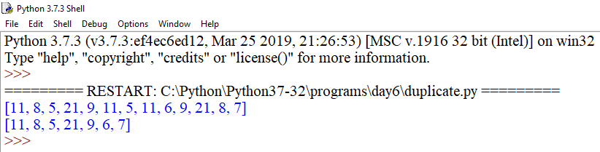

**#Using sets**

lst=[11,8,5,21,9,11,5,11,9,21,8]

print(lst)

new_set=set(lst)

lst=list(new_set)

print(lst)

**OUTPUT**

